TS INSERTER MANUAL

Contents

How to setup – Scenario 1 2

How to setup – Scenario 2 5

How to use, Scenario 1 7

How to use, Scenario 2 9

How to print a label 10

Initialisation and Setup

When first loading ‘TS Inserter’, no settings will have initialised.  
The program will be in an unusable state. (Figure 1.1.1)  
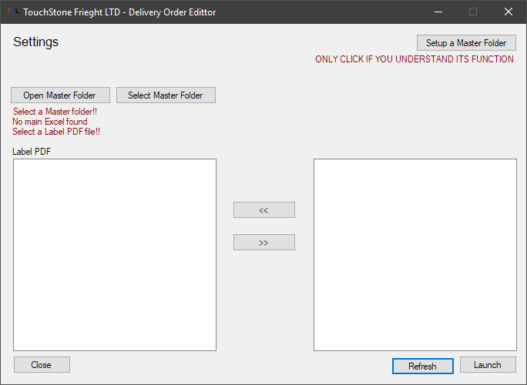

Figure 1.1.1

# How to setup – Scenario 1

This is when the program is in a fresh start unusable state.

1. Make sure a master folder is setup.   
   Open file explorer, navigate to **DROPBOX > A TOUCHSTONE FREIGHT SERVICES > ORDERS > LABELS**Check for the folders: Archives, Master, temp, Insert Label PDFs to edit   
   Check for the file: Label.lbx  
   Open folder **Archives** and check for folders: XLSX and PDF  
   If at least 1 one these folders/files doesn’t exist move to step 2 otherwise skip to scenario 2
2. Press **Setup a master folder** (Figure 1.1.2), a folder selection dialogue will open. Navigate to **DROPBOX > A TOUCHSTONE FREIGHT SERVICES > ORDERS**select the folder **LABELS** and press ok (Figure 1.1.3) and then press yes.  
   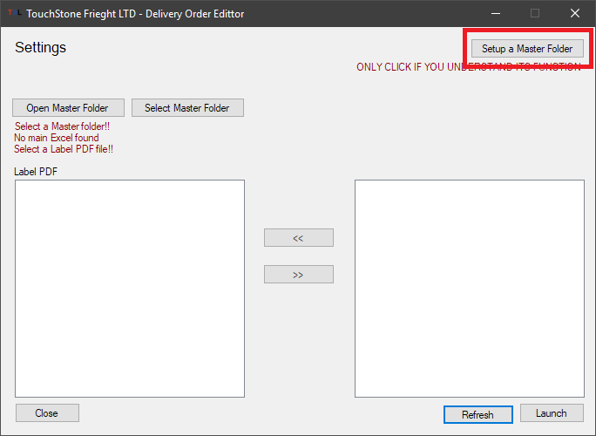  
   Figure 1.1.2  
   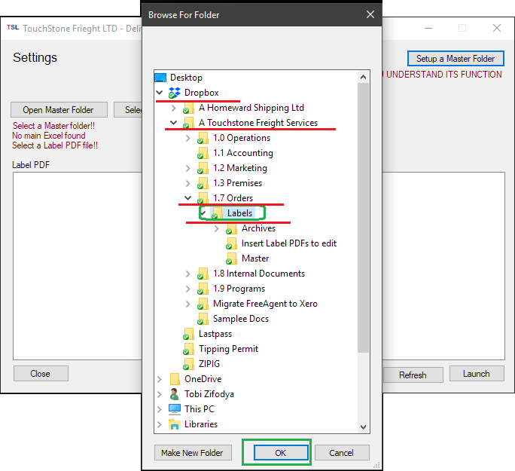  
   Figure 1.1.3
3. Program should now be setup correctly. Like Figure 1.1.4  
   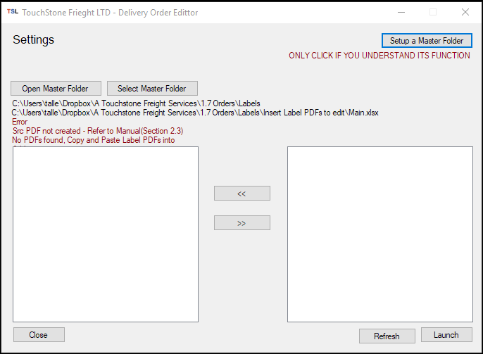

Figure 1.1.4

1. Now move onto **page 7, section “How to use Scenario 1”**

LEFT EMPTY

# How to setup – Scenario 2

This is when all folders from scenario 1 step 1 exist.

1. **After**, having checked the required folders and files, and they all exist.  
   Press **Select a master folder** (Figure 1.2.1), a folder selection dialogue will open. Navigate to **DROPBOX > A TOUCHSTONE FREIGHT SERVICES > ORDERS**select the folder **LABELS** and press ok (Figure 1.2.2) and then press yes.

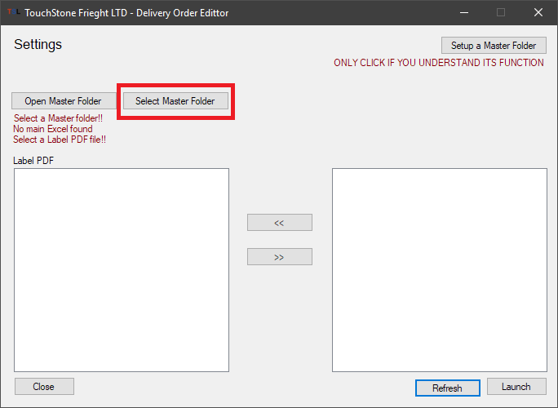  
Figure 1.2.1

  
Figure 1.2.2

1. Program should now be setup correctly. Like Figure 1.2.3

Figure 1.2.3

1. Now move onto **page 7, section “How to use Scenario 1”**

LEFT EMPTY



Figure 1.3.1

# How to use, Scenario 1

In this scenario, you will learn how to use the program from a fresh usable state. This is in follow up from the previous pages, Initialisation and Setup.

1. You should see a program screen like in Figure 1.3.1
2. On the program there are 2 big white boxes.   
   The one on the **Left** shows the PDF files in the folder **\Dropbox\A Touchstone Freight Services\1.7 Orders\Labels\Insert Label PDFs to edit\**   
   The one on the **Right** shows the PDF files in the folder **\$User\Downloads\** aka the ***downloads*** folder
3. From here, the program requires that you have purchased and downloaded a Label PDF from the Ipostparcels Website.
4. If you press the **REFRESH** button in the bottom right, the right white box should show a label present. Figure 1.3.2

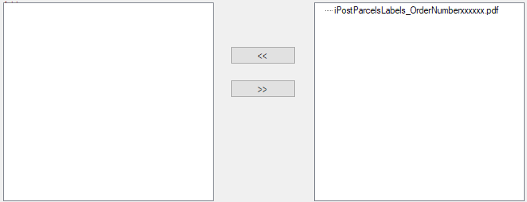  
Figure 1.3.2

1. If more than 1 label is present in your ***downloads*** folder, more than 1 item will appear in the right box.
2. Select the wanted labels and press the **<<** arrows to move them into the left box.  
   Figure 1.3.3  
   *Duplicate pdfs will not be moved.
3. Press **REFRESH** in the bottom right then press yes.  
   The program should update like Figure 1.3.4  
   A ***SRC.PDF*** file should be generated and show in the left white box  
   Red text above should indicate the numbers of labels found between all the labels.  
   The black text below it, indicates the number of PDFs found in the left box excluding ***SRC.PDF***
4. You can repeat step 3 to step 7 to make sure all your labels are placed into the left box.
5. Once ready press launch.

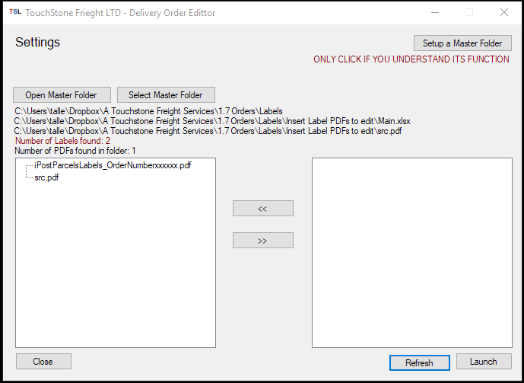

Figure 1.3.4

# 

LEFT EMPTY

# How to use, Scenario 2

1. When launched is pressed, a new window should appear. This window autogenerates the labels data into simple text fields. Figure 1.3.5
2. Simply check the information in each text field. If information is wrong, it can be corrected by clicking the text box and changing the data.
3. After checking the textbox, some have a red tick box next to the field. This means the tickbox must be checked to advance on.  
   **A *TICKALL* button is available to click to speed up the ticking process.**
4. If a page is correct press Next. If the label page is only 1, press finish. Then press OK
5. TS Inserter can now be closed.
6. Move to page 9, **“How to print a label”**.

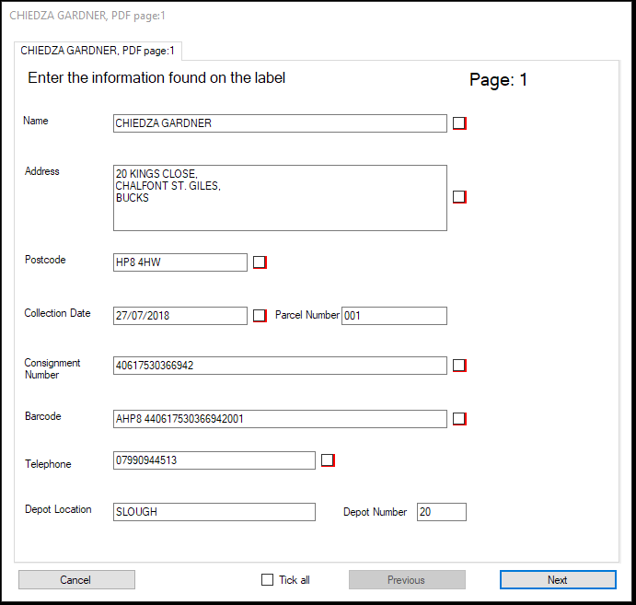  
Figure 1.3.5

# How to print a label

After TS Inserter is closed. You move onto creating your label using P Touch program. Make sure label printer is connected and switched on.

1. Open P touch program Figure 1.4.1 and Figure 1.4.2
2. You are presented with the splash page Figure 1.4.3, select Open in the top left, press my computer, then navigate to **DROPBOX > A TOUCHSTONE FREIGHT SERVICES > ORDERS > LABELS** and select ***Label.lbx***  Figure 1.4.4

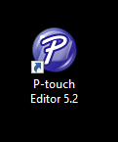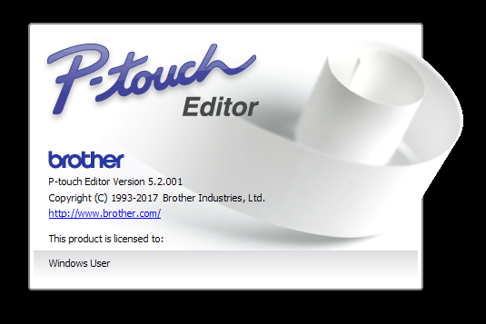  
Figure 1.4.1 and 1.4.2



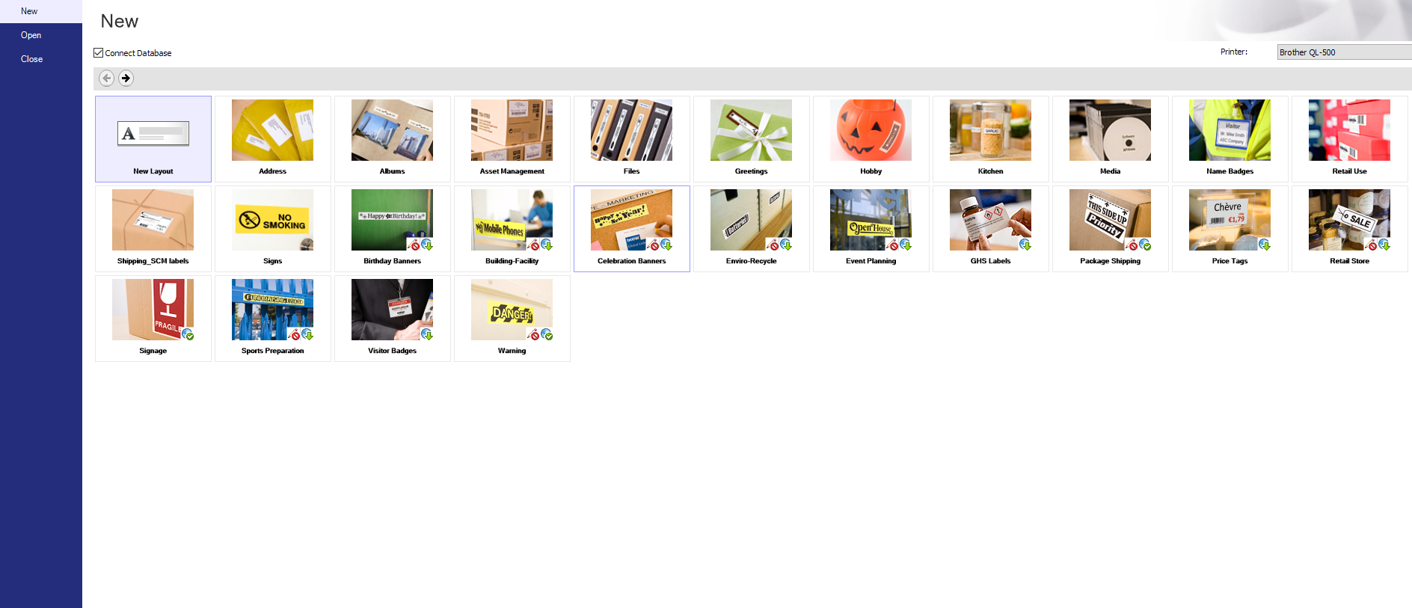  
Figure 1.4.3

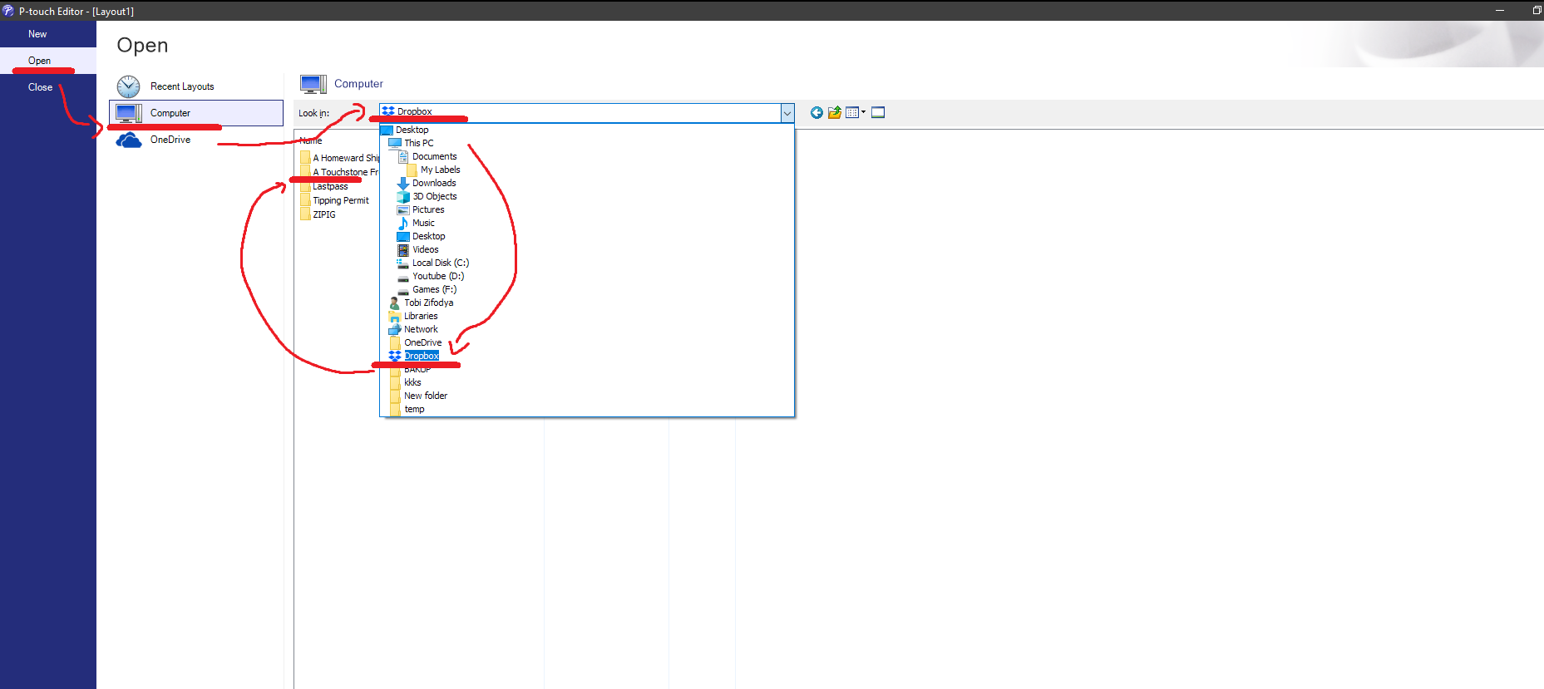  
Figure 1.4.4

1. During the first time loading, you will be presented with a message box, Figure 1.4.5  
   Press yes and Navigate to **DROPBOX > A TOUCHSTONE FREIGHT SERVICES > ORDERS > LABELS > INSERT LABEL PDFS TO EDIT,** open the file ***MAIN.XLSX***
2. You will then be presented with a screen like figure 1.4.6.  
   Start by pressing save at the top.
3. At the bottom there is a table of label addresses. Simply select on the row you want, most recent are at the bottom of the table.  
   The label will then change depending on which row is selected. Figure 1.4.7 and 1.4.8
4. Then press print. To print a label

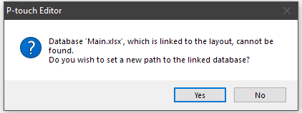



Figure 1.4.5

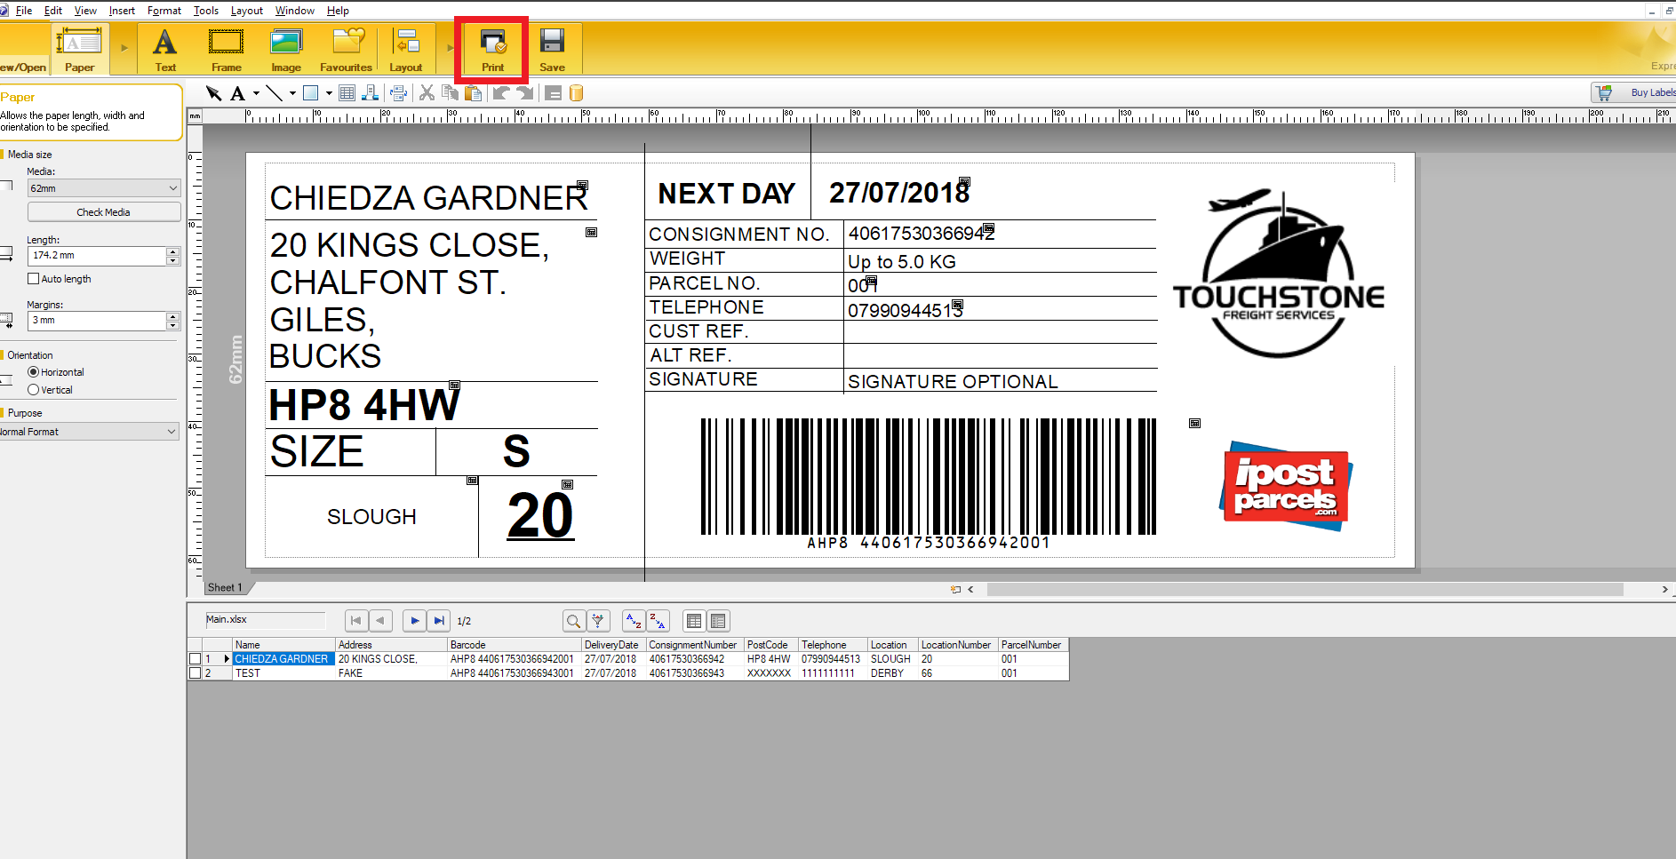  
Figure 1.4.6



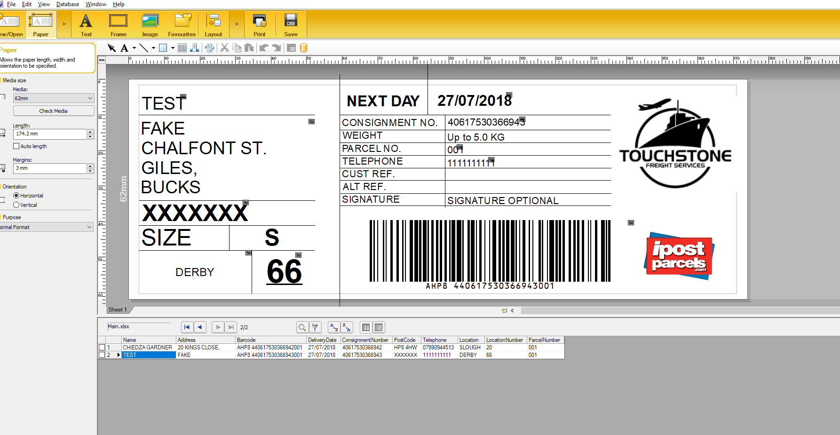  
Figure 1.4.7



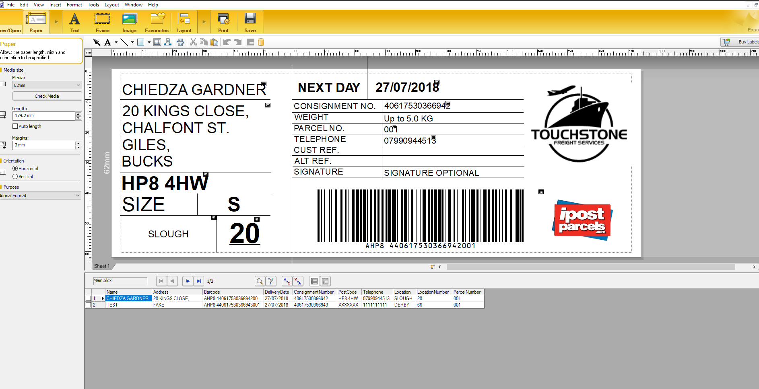  
Figure 1.4.8

